Agrobot competition
Research proposal

Fontys Venlo
22-09-2023

By Boris Bonchev, Tom Jacobs, Nils Kronig, Duarte Somsen and Liz van Tienoven.
Content

Version control 3
Dictionary 3
Introduction 3
Background information 4
Description of goal 5
Description of problem 6
Main research question 7
Sub question 1 8
Sub question 2 8
Sub question 3 8
Sub question 4 8
Sub question 5 8
Sub question 6 8
The 5 Why’s 8
Research structure 8
Milestones 9
Appendix 10
Appendix 1: Existing farming robots 11
Appendix 2: Soft end-effector technology 11

Version control

Version | Purpose/Change | Date
0.1 | Initial draft - proposal | 22/09/2023

Dictionary
Term | Definition
AI | Artificial Intelligence
Agrobot | Autonomous agricultural robot
Pixel farming | Farming technique where a field is divided into small cells, or “pixels”.
End-effector | The part of the robot which will grab the crop for harvesting.

Introduction
Agriculture is one of the most important aspects of our society, especially in The Netherlands since it is the biggest export. However, the demand for agriculture is constantly increasing, so there is a pressing need for efficiency and sustainability. One way to achieve this is to develop robots which can perform agricultural tasks such as planting, weeding and harvesting.
The goal of this research project is to design an autonomous robot, which will be capable of harvesting and sorting crops into colored bins. The robot will operate on a pixel farm consisting of planter boxes, each planter box is divided into nine crop pixels. The planters will contain lettuce, beets, carrots and radishes, planted randomly. The robot will have to navigate to the crops, recognize them and sort them into the appropriate bin.
This research proposal will provide a detailed plan for achieving this goal. First, the background information will be described as well as the explanation of the problem. We will then outline the structure of our research in which we will explain how we plan to go about solving the problem.

Background information
Agricultural robotics is a field that is trying to automate farming tasks to increase productivity and efficiency. There has been a significant amount of research in this area, with prototypes capable of planting, weeding, harvesting and data collection [1].
Another key area of research in this field is how robots can best grip plants to harvest them. This requires technology to gently grip and detach the plants without leaving any damage to the plant. Soft end-effector technology has shown promise for this application, because of its versatility, and the gentle interaction forces [2]. Elfferich et al. Reviewed soft end-effectors for harvesting applications. They found 78 end-effectors based on academic literature, however only 15 end-effectors were actually tested on success rate.

Description of goal
The primary goal of this research is to develop an autonomous crop harvesting robot with the capability to harvest a variety of crops. This ambitious project aims to design and construct a robot that can independently navigate agricultural fields called pixels, creating its own path through the field. Key areas of focus include ensuring the robot's versatility, enabling it to effectively harvest various types of crops, and prioritizing efficiency and precision in the harvesting process. Additionally, this research will explore the benefits of pixel farming in conjunction with robot development, further enhancing the potential for revolutionary advancements in agriculture.

Description of problem
The concept of pixel farming faces a significant challenge in agricultural research and practice. This challenge exists because of two critical factors:
- Limited Demand: The adoption of the Pixel Farming approach encounters restricted acceptance and interest within the agricultural community. This can be attributed to the fact that the benefits and potential of this method have not been sufficiently explored or understood. Farmers and agricultural enterprises hesitate to embrace Pixel Farming due to their limited knowledge of its concrete advantages and effects.
- Lack of research: In parallel, there is a lack of scientific research and studies in the field of pixel farming. The limited enthusiasm and demand for this method has so far prevented the research community from conducting extensive and in-depth analyses. As a result, there is a lack of in-depth knowledge that hinders the further development and implementation of pixel farming.
This problem arises from a complex interplay between demand and research and requires an interdisciplinary approach to fully unlock the potential of pixel farming in modern agriculture.
Furthermore, we face an issue because we currently lack the suitable machines and robots required for pixel farming. As a result, engaging in pixel farming isn't a practical option at the moment. While the necessary technology exists, there's no way to put it to the test or apply it effectively in a pixel farming context. This is why our team is here – to push forward in developing the robot needed for this purpose.

Main research question
How can a farming robot be developed that needs to be able to harvest and sort lettuce, carrots, beets and radish on a pixel farm?

Sub question 1
How is pixel farming accomplished by other researchers?

Sub question 2
How can a robot see and recognize different types of crops?

Sub question 3
How can a robot autonomously move around the crops and from the crops to the sorting bins and back?

Sub question 4
What is a suitable end-effector design so that a robot can harvest different types of crops?

Sub question 5
How to design a robot that can effectively and reliably move in a field?

Sub question 6
How can a robot harvest a pixel farm most efficiently?

The 5 Why’s
- Why did pixel farming arise?
- Why one universal robot instead of multiple specialized robots?
- Why is having a universal robot more cost effective than multiple specialized robots?
- Why are autonomous robots needed in pixel farming?
- Why do autonomous robots offer a solution to labor shortages?

Research structure

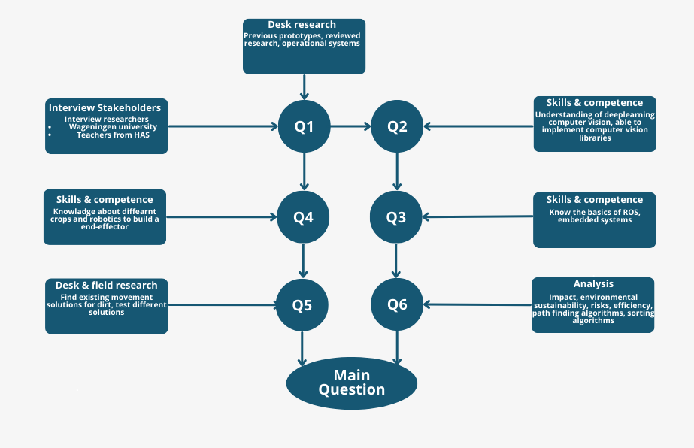

Milestones

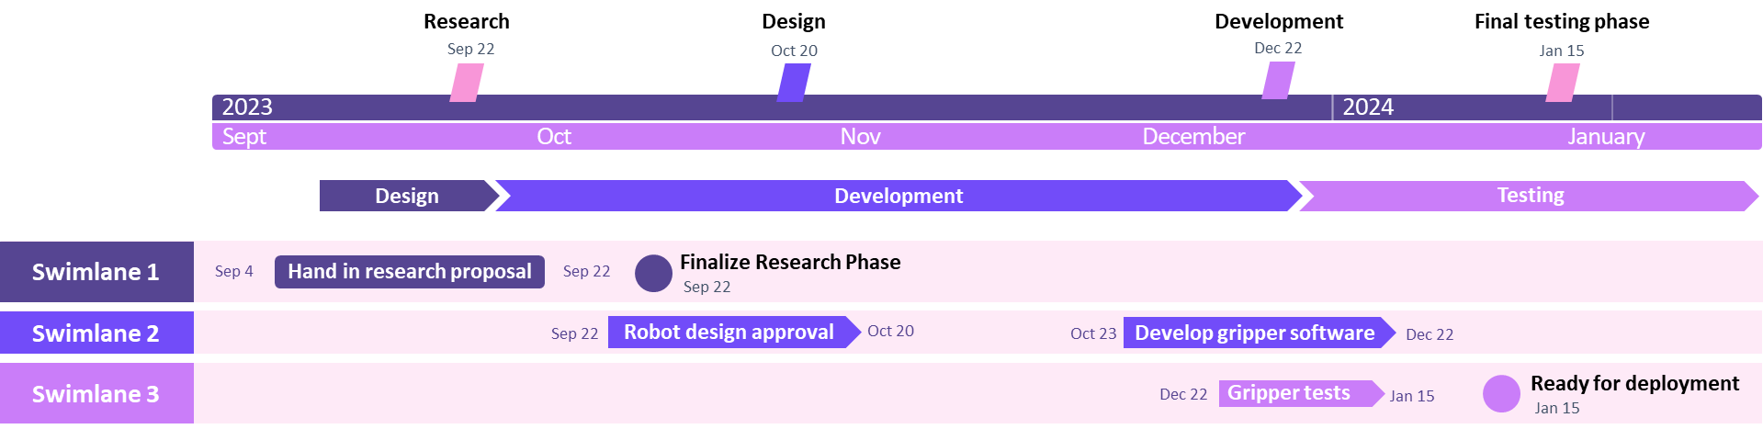
- Finalize research on the topic of pixel farming and obtain approval to start the development of the robot.
- Complete design of the robot, end-effector and any additional parts that might be needed.
- Get approval for the design of robot and make additional changes wherever it is needed.
- Start development of the robot.
- Build the first prototype and begin initial testing.
- Develop functional movement of the robot.
- The building of the end-effector is complete.
- Finish the development of the AI software which detects the crops.
- Develop the software for the end-effector.
- Final testing on the movement of the robot.
- Final testing on the AI and computer vision.
- Final testing of the end-effector.
- Robot is ready for deployment.

Appendix

Appendix 1: Existing farming robots
This paper shows a multi-robot system capable of automatically performing farming tasks.
https://ntnuopen.ntnu.no/ntnu-xmlui/bitstream/handle/11250/2595468/4278-13703-4-PB.pdf?sequence=1&isAllowed=y

Appendix 2: Soft end-effector technology
This paper reviews research around soft end-effector technology. They give an overview of existing solutions for gripping crops to harvest them.
https://pure.tudelft.nl/ws/portalfiles/portal/127734420/Soft_Robotic_Grippers_for_Crop_Handling_or_Harvesting_A_Review.pdf

Appendix 3: Heinze-Oost model
Sub-question 1: | How is pixel farming accomplished by other researchers?
Reason of the question | Determining ways, we can accomplish building the robot.
Wanted answer | Research papers of current best practices in pixel farming
Knowledge domains | Agriculture
Method/strategy | Literature review

Sub-question 2: | How can a robot see or recognize different types of crops?
Reason of the question | Find ways for enabling a robot to visually see and distinguish between different types of crops in a pixel farm.
Wanted answer | A camera that can successfully distinguish different types of crops in a pixel farm
Knowledge domains | Computer Vision
Method/strategy | Prototyping

Sub-question 3: | How can a robot autonomously move around the crops and from the crops to the sorting bins and back?
Reason of the question | Explore the methods and strategies for enabling a robot to operate autonomously in an agricultural setting, navigating between crops and sorting bins efficiently.
Wanted answer | An overview of the knowledge domains, methods, and strategies used to achieve autonomous robot movement in agricultural robots.
Knowledge domains | Robotics and Software
Method/strategy | Prototyping

Sub-question 4: | What is a suitable end-effector design so that a robot can harvest different types of crops?
Reason of the question | Create design considerations and strategies required to develop an effective end-effector for a robot that can harvest a variety of crops.
Wanted answer | An effective end-effector design to harvest multiple different types of crops.
Knowledge domains | Agriculture and Robotics
Method/strategy | Research & Prototyping

Sub-question 5: | How to design a robot that can effectively and reliably move in a field?
Reason of the question | The Robot needs to navigate the farm without getting stuck or losing its course. It also needs to move at a reasonable speed and turn in a small radius, to accomplish time goals.
Wanted answer | A robot design or concept, that enables the robot to move at a reasonable Speed, turn as desired and navigate a Field without getting stuck.
Knowledge domains | Robotics and Mechanics
Method/strategy | Research

Sub-question 6: | How can a robot harvest a pixel farm most efficiently?
Reason of the question | The robot needs to harvest as fast as possible
Wanted answer | A strategy or method that the robot can use to Harvest the most Plants in the least time.
Knowledge domains | Robotics and Agriculture
Method/strategy | Desk Research

